Preparatory Phase for the Einstein Telescope Gravitational Wave Observatory

Milestone 04.02

Common methodology to estimate impact of site characteristics on ET sensitivity and operation and, if required, a scheme to compensate it

ET- 0XXX-24

Lead beneficiary:
Delivery Date: XXXXXXXXXXXXX 2024
Dissemination level: public
NAME : ET-PP-Milestone-04.02
Version: 1.0

This project has received funding from the European Commission Framework Programme Horizon Europe Coordination and Support action under grant agreement 101079696.

Document information

Grant Agreement Number | 101079696
Acronym | ET-PP
Start date of project (Duration) | 01/09/2022 (48 months)
Document due date
Authors
Milestone number | 2
Milestone name | Document detailing the site-specific characteristics that impact ET sensitivity and its duty cycle.
WP | 4

Version | Date | Author | Description
v 0.1 | June 13th 2024 | D. D’Urso, W. Walk | Creation

EXECUTIVE SUMMARY

This document, Milestone 4.2 “Common methodology to estimate impact of site characteristics on ET sensitivity and operation and, if required, a scheme to compensate it”, is a milestone of the ET-PP Project, which is funded by the European Commission Framework Programme Horizon Europe Coordination and Support action under grant agreement 101079696.
This Milestone is a crucial step towards the definition of a fair site evaluation procedure and it requires a full understanding of the role of environmental noise and site characteristics on detector performance.
Environment may play an important role, affecting cost, lifetime and detector behavior. The report will describe the methodology defined to evaluate the detector site dependent detector performances.
Table of Contents
Introduction 2
Methodology Scheme 3
Definition of Science Cases and of Analysis Recipes 3
Definition of Tools for detector behavior and Mitigation Strategy 4
Definition of Relevant Measurements 4
Site Noise Measurements: data acquisition and validation 4
Evaluation of Detector Sensitivity 4
Validation 4
Risk assessment of mitigation effectiveness 4
Timeline 5
References 5

Introduction

Site evaluation for ET construction is a very complex procedure in which many aspects should be considered: construction feasibility, costs, authorization and legal aspects and possible site dependent detector performance.
Einstein Telescope is expected to reach a sensitivity, at low frequencies, well beyond those obtained by current 2G detectors (at 3 Hz the difference will be more then 5 order of magnitudes) and that amplifies the importance of environmental noise.
Site conditions (e.g. geological and geodynamical features, ground water) influence the construction feasibility, costs and lifetime of the infrastructure and, at the same time, may impact detector performance (e.g. underground water flow may produce Newtonian Noise). On the other hand, environmental noises (e.g. seismic motion) have a direct impact on the detector sensitivity and duty cycle.
Based on the experience of managing current 2G detectors, the ET Collaboration has been able to identify site characteristics that may have an impact on the detector (D. D'Urso, 2024) and it is evaluating their effects on the interferometer.
Seismic fields need special attention since the main environmental noise predicted to set a low-frequency limit to ET’s bandwidth was from gravity perturbations produced by seismic fields, so-called Newtonian Noise (NN). For site characteristics that may limit the detectors performance, special mitigation strategies should be implemented. For NN mitigation a very complicated method is required.
Local magnetic noise as well as Schumann resonances could introduce limitations to the gravitational wave detection of future Earth-based gravitational-wave detectors.
In this document a common methodology to assess the impact of site environmental noise on the apparatus is described, considering detector functionality and the different ET scientific targets provided by the ET Collaboration (ETC).

Methodology Scheme

A possible methodology that can be applied for a site evaluation on scientific bases can summarized in the following steps:
- Define science cases relevant for site dependent detector performance, likely low frequency scientific targets
- Define tools to be used to estimated detector behavior, given a specific environmental configuration
- Define analysis recipes to be followed to evaluate detector potentialities with respect to science cases of point 2
- Define relevant measurements to be performed, following specific standards
- Measurements of environmental noise, acquisition and validation
- Evaluation of detector performance
- Result validation by ETC
- Analysis for noise mitigation strategies and evaluate possible additional costs
- Evaluation of detector performance considering mitigation strategies of point 6
- Result validation
- Risk assessment of mitigation effectiveness, considering additional costs, time and person-power needed.

In Figure 1 the diagram of the process is summarized.

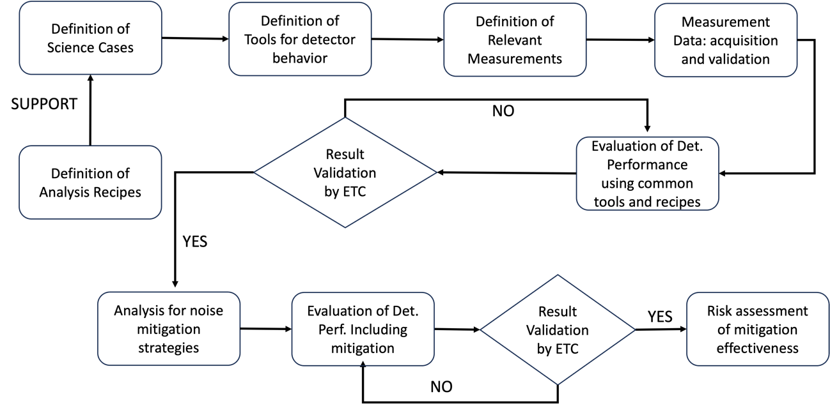
Figure 1 Methodology Scheme

Definition of Science Cases and of Analysis Recipes

There is a huge effort in the ETC to define the science case for the Einstein Telescope. This involves studies of different detector configurations, construction of the data analysis platform, exploration of the computational needs for optimum science extraction and the interaction between ET and other GW/non-GW observatories. The Observational Science Board (OSB) of ETC is fully devoted to identify ET science goals and provide common tools and an analysis platform. OSB will provide the list of science cases that needs or may benefit of low frequency GW detection, the recipes and common tools to be used by local teams in their analysis.

Definition of Tools for detector behavior and Mitigation Strategy

In the ETC the Instrumental Science Board (ISB) has been established to develop the ET Detector Technical Design Report. ISB is structured in different Working Divisions and it will provide the tools to estimate the effect of different site environmental noises on detector behavior and possible mitigation strategy to compensate them.

Definition of Relevant Measurements

The environment has an important role in a third-generation gravitational wave (GW) observatory like ET, which one of the most crucial goals is to observe GW in the frequency range 2-10 Hz.
ETC established a board fully devoted to define the relevant site parameters for detector functionality, the Site Characterization Board, that is providing the list of relevant measurements to be performed in each candidate site and the standard to be followed.
Site characteristics that may have an impact on the Einstein Telescope (ET) are summarized in (D. D'Urso, 2024).

Site Noise Measurements: data acquisition and validation

Measurements should follow standards set by ETC. Local team have to provide all the quantities identified by ETC with verified and well documented tools to perform a basic analysis. Data and tools should be well documented and shared to the whole ETC.

Evaluation of Detector Sensitivity

Following the inputs and making use of common tools and recipes provided by the different bodies of ETC, local teams must evaluate the detector sensitivity for each of the identified science targets.

Validation

Results of local team studies should be verified by the relevant ETC bodies that provided tools and recipes to ensure that they have been correctly used.

Risk assessment of mitigation effectiveness

Based on the obtained results, local team should assess the risk of a possible scientific descoping due to mitigation effectiveness, considering additional costs, time and person-power. Risk assessment should be done in agreement with standards defined by ETC.

Timeline

In the ESFRI Proposal there was a clear timeline for the output of the process: M28 (end of 2024!)

References
(D. D'Urso, 2024)
(Amann, F. et al., 2020)
(Naticchioni, et al., SPB-WD1-M1.1, 2023)
(Naticchioni, et al., SPB-WD1-M1.2)
Figure SEQ Figure \* ARABIC 13 Statistics and leading actors in the GW patent ecosystem. Source: Orbit Insight

